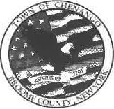 | TOWN OF CHENANGO
 | WATER, SEWER AND PARKS DEPARTMENT Greg Burden, Superintendent of Public Works | 1529 NYS Rt. 12 Binghamton,NY 13901 Telephone: (607) 648-4809 ext7 Fax: (607) 648-8519 water@townofchenango.com

4/30/2026

Please take notice: the Boil Water Advisory in effect for the Chenango Bridge/12A water service area has been lifted. The Town of Chenango's water system has passed the Broome County/NYS Health Department testing requirements for return to normal operations.

Thank you!
Gregory Burden
Town of Chenango

